**WEKA Sentiment Analysis**

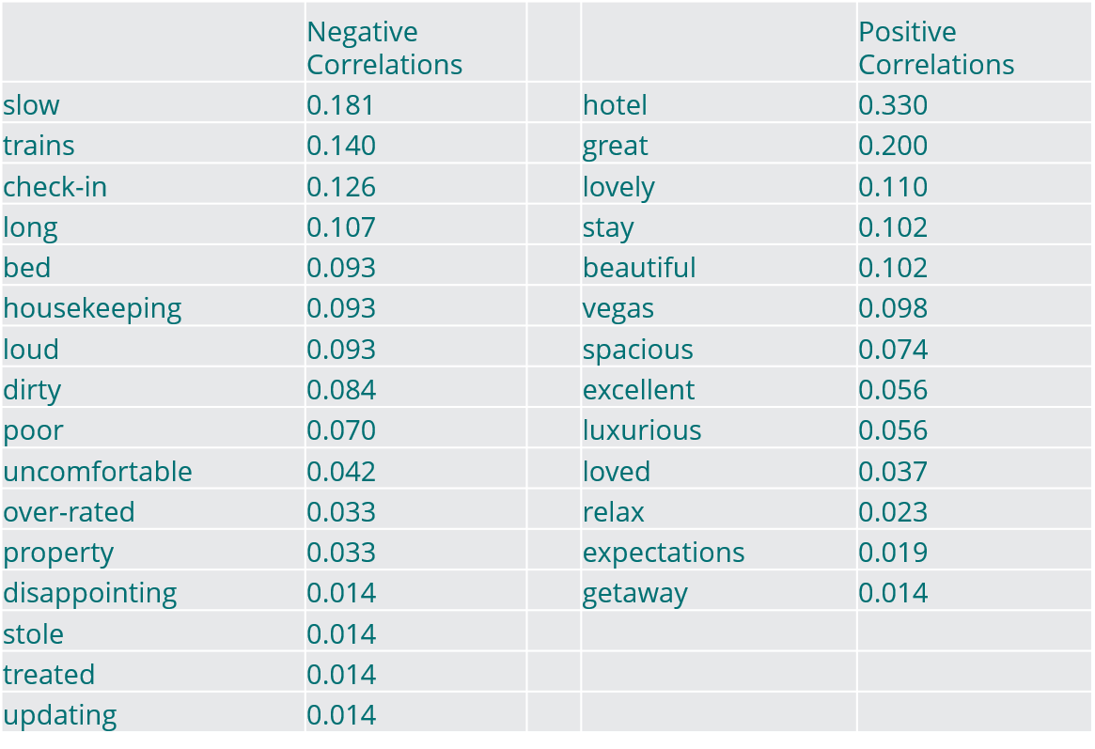

**Q1: What can you summarize from this information?**

These correlations tell me that negative reviews were the result of slow service, loud trains, and housekeepers not doing their jobs properly. I can also see that positive reviews resulted from people being excited about Vegas, the luxurious atmosphere of the hotel, and the size of rooms.

**Q2: What services need improvement?**

Check-in process, noise from passing trains, and unsatisfactory cleaning done by housekeeping. I recommend bringing in an Operations specialist to renovate the check-in process, adding noise cancellers to windows, and analyzing who is slacking off on the housekeeping team.

**Q3: How might you use this information to shape your advertising campaign or to target your customers?**

The hotel building and location should be emphasized in ads targeting customers in need of a beautiful, relaxing getaway. I would feature the positive reviews in a digital marketing campaign showing the pools, large rooms, Vegas casinos, and the hotel spa.